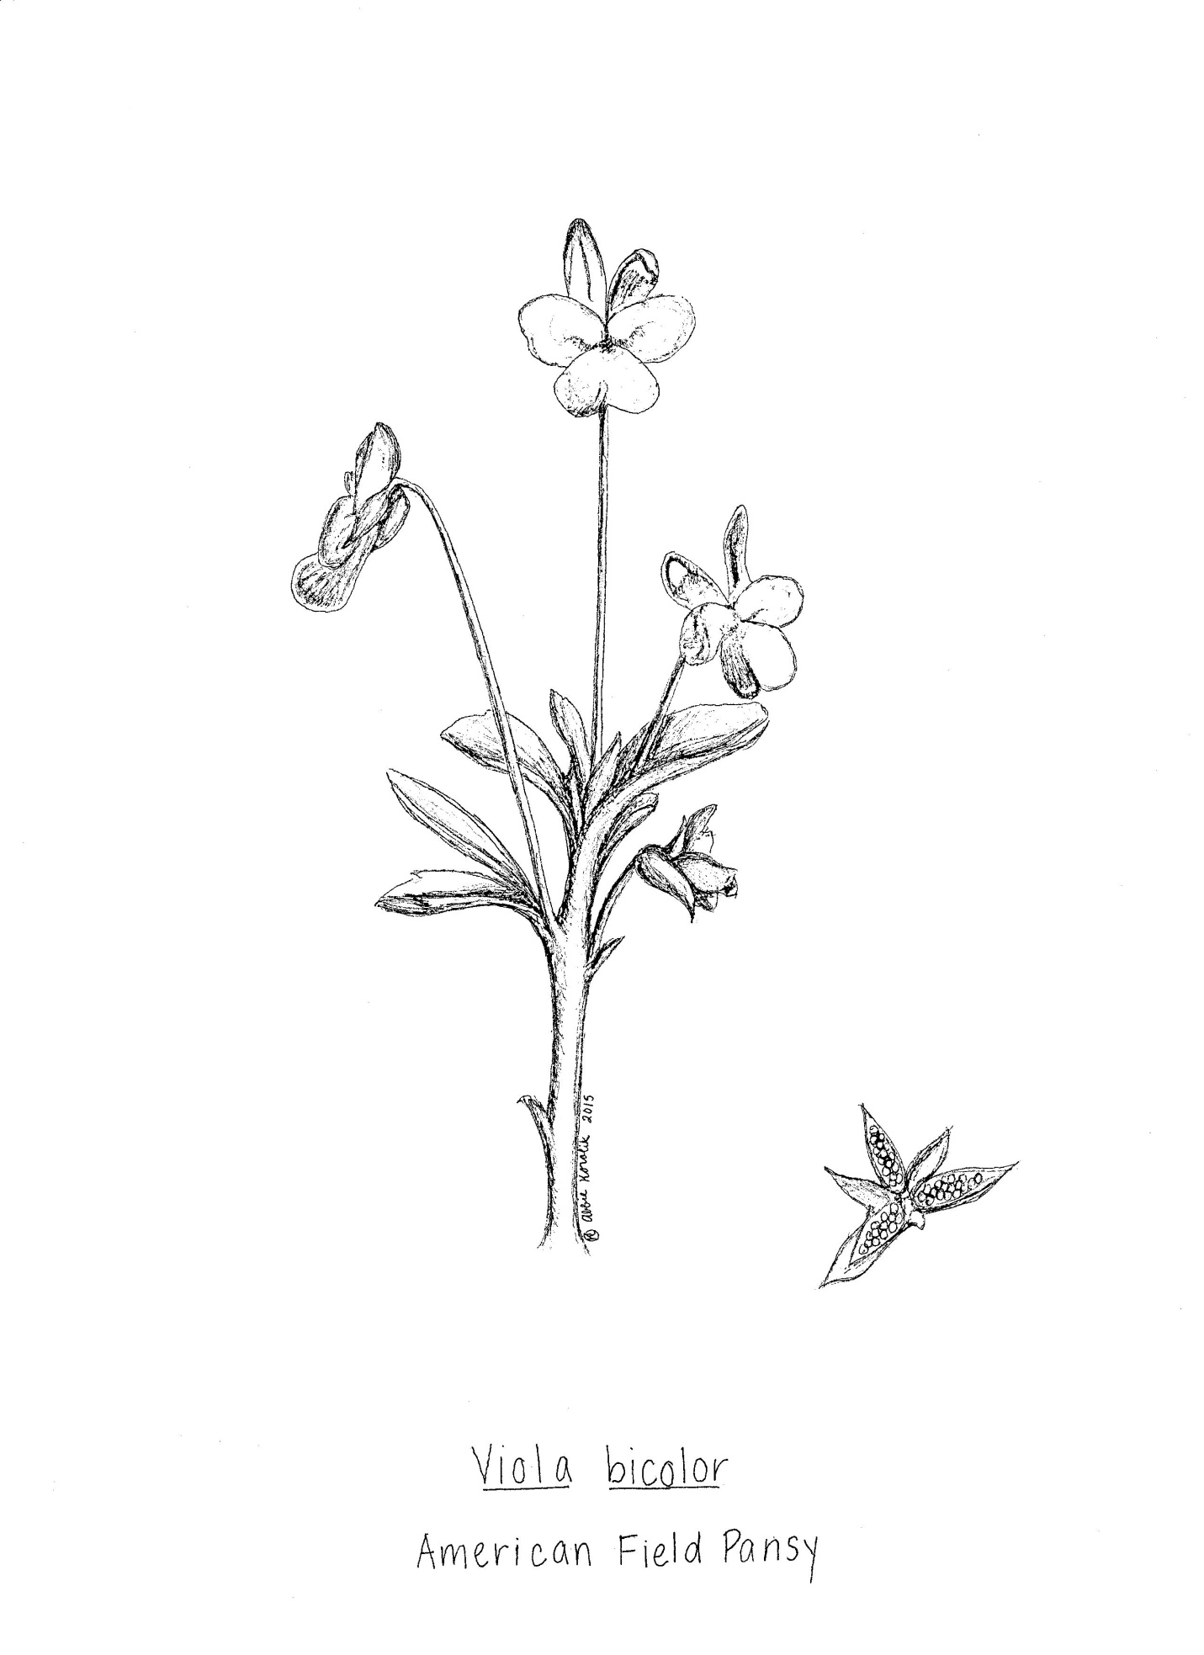

Sometimes the most minimalistic botanical illustrations depict the plant in the best manner, such as the American Field Pansy above, paired with a drawing of one of its seed pods.