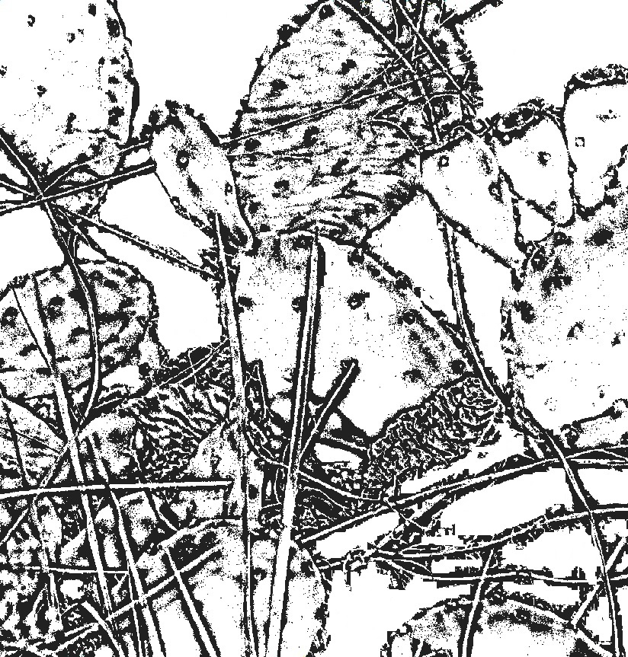

Prickly Pear Cacti are often found in groups on Sandy Hook.

A Prickly Pear Cactus has flatter leaves than an ordinary cactus, and has flowers at the top of their leaves, which are a pink/purple color.