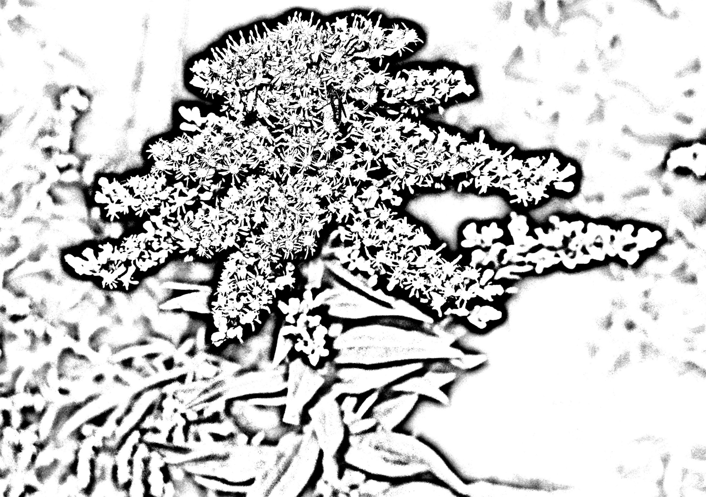

Seaside Goldenrod’s scientific name is *Solidago sempervirens*. Seaside Goldenrod grows up to four feet in height and has distinguishing flowers that are a yellow-gold color.