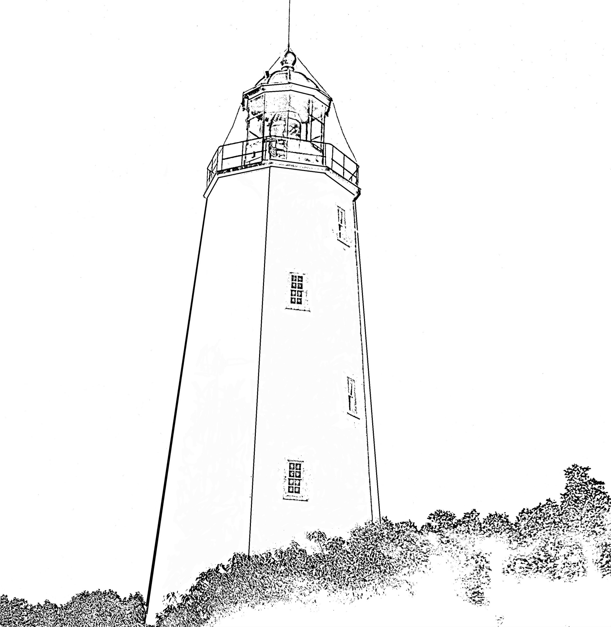

*Erin Manaut*

Built in 1764, the Sandy Hook Lighthouse is the oldest working lighthouse in the United States. When originally established the lighthouse was at the tip of the hook, but the land has since changed.