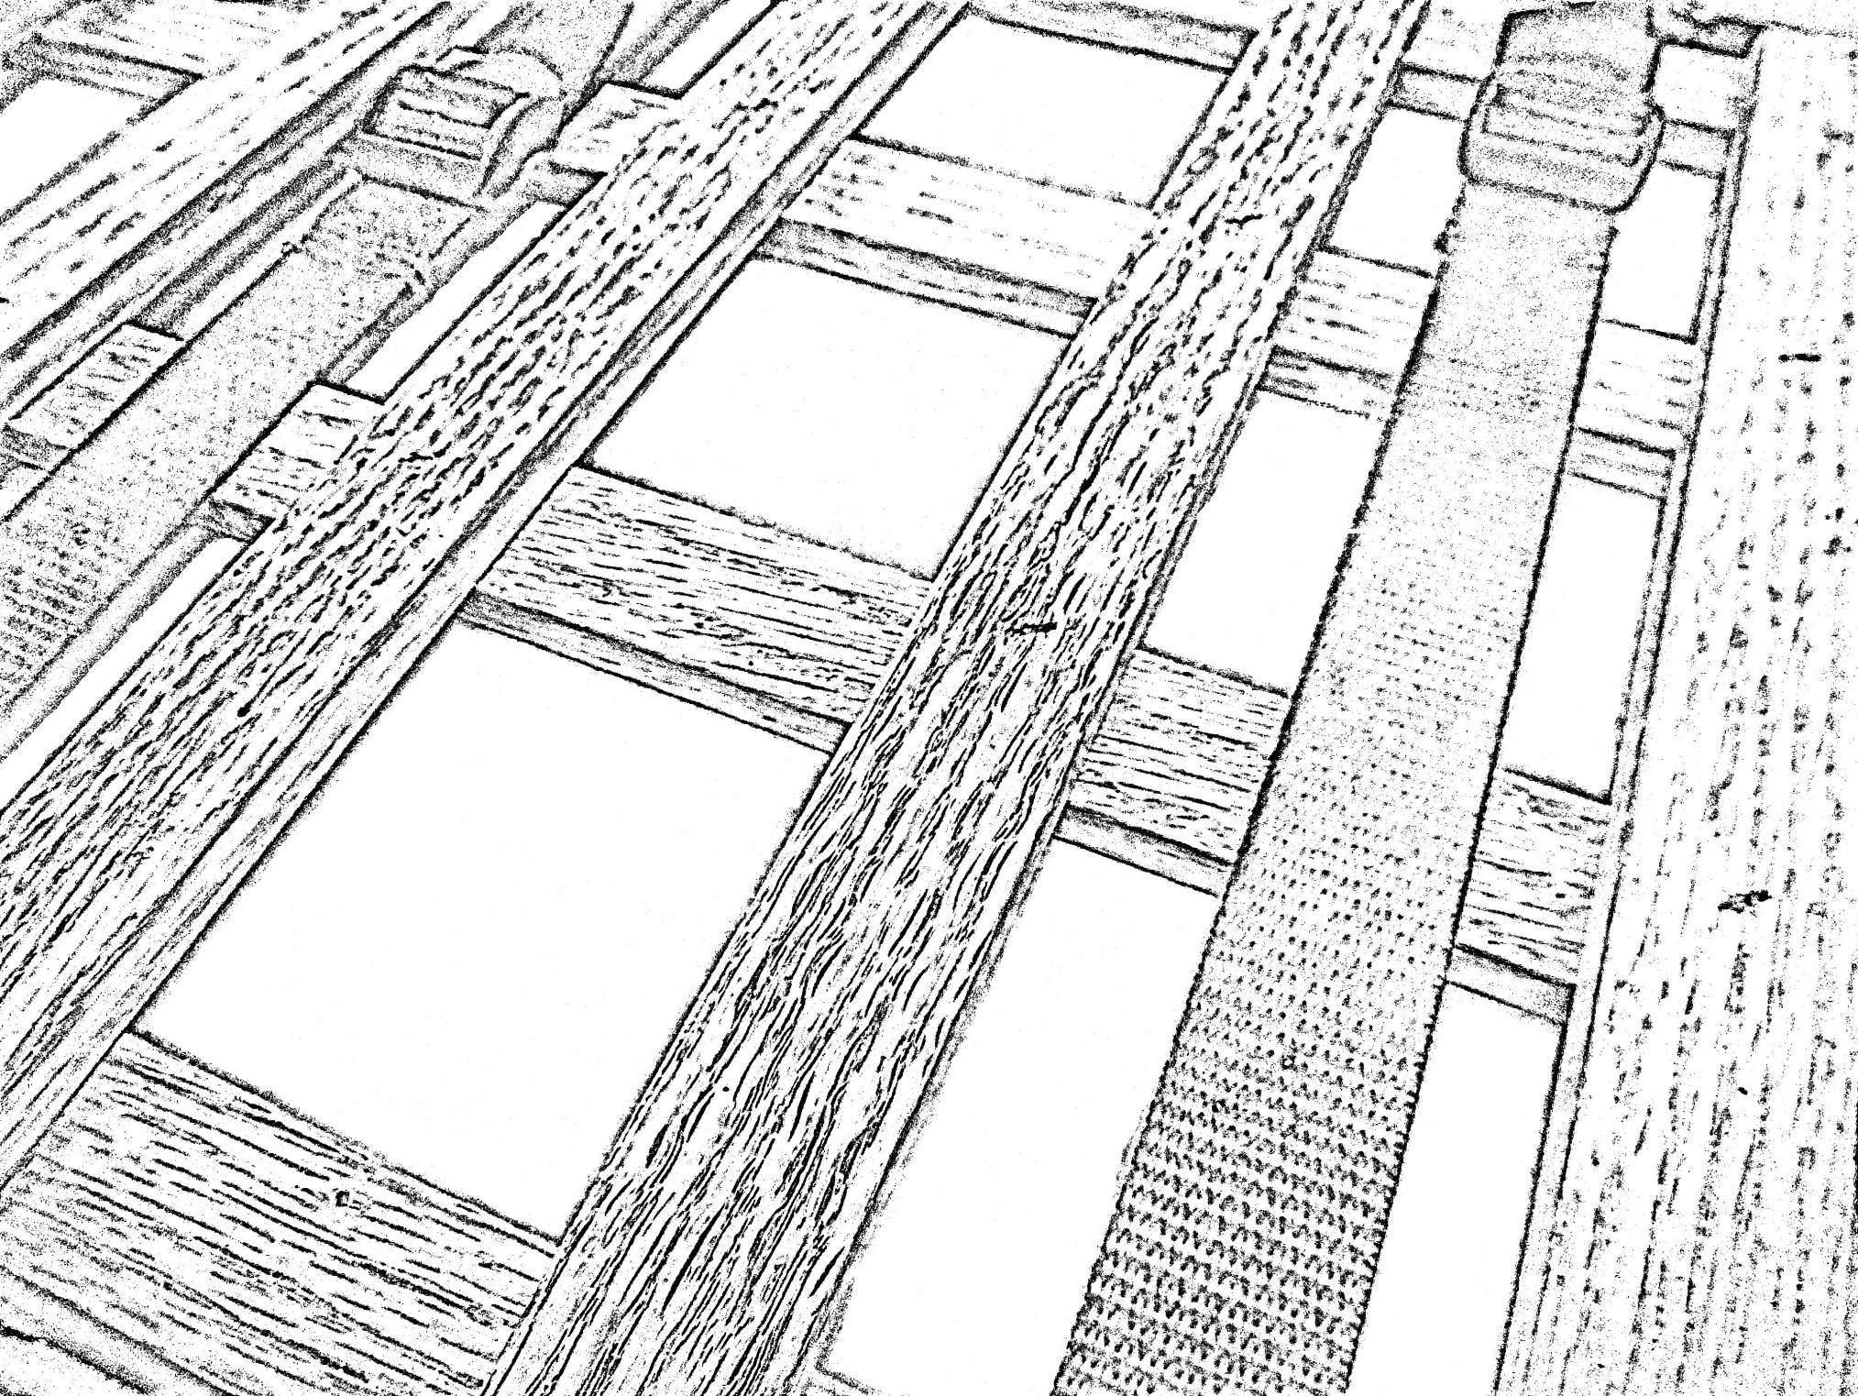

A plant press is made using latticed pieces of wood. The two sides of a plant press are strapped together with the plants, along with other materials, in between.