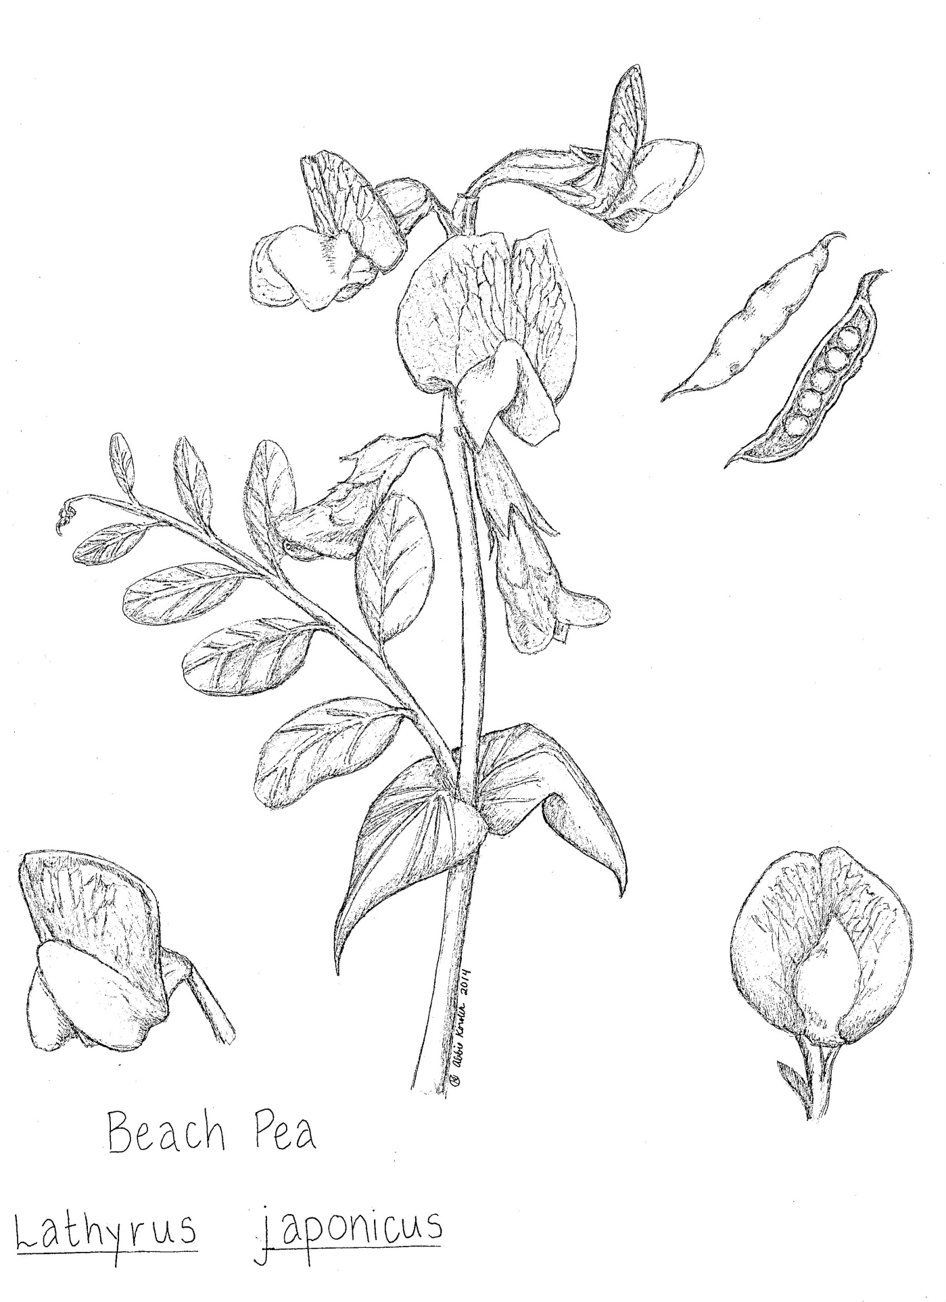
The art department of the Sandy Hook Interactive Herbarium draws botanical illustrations of native plants, like this one of beach pea!

