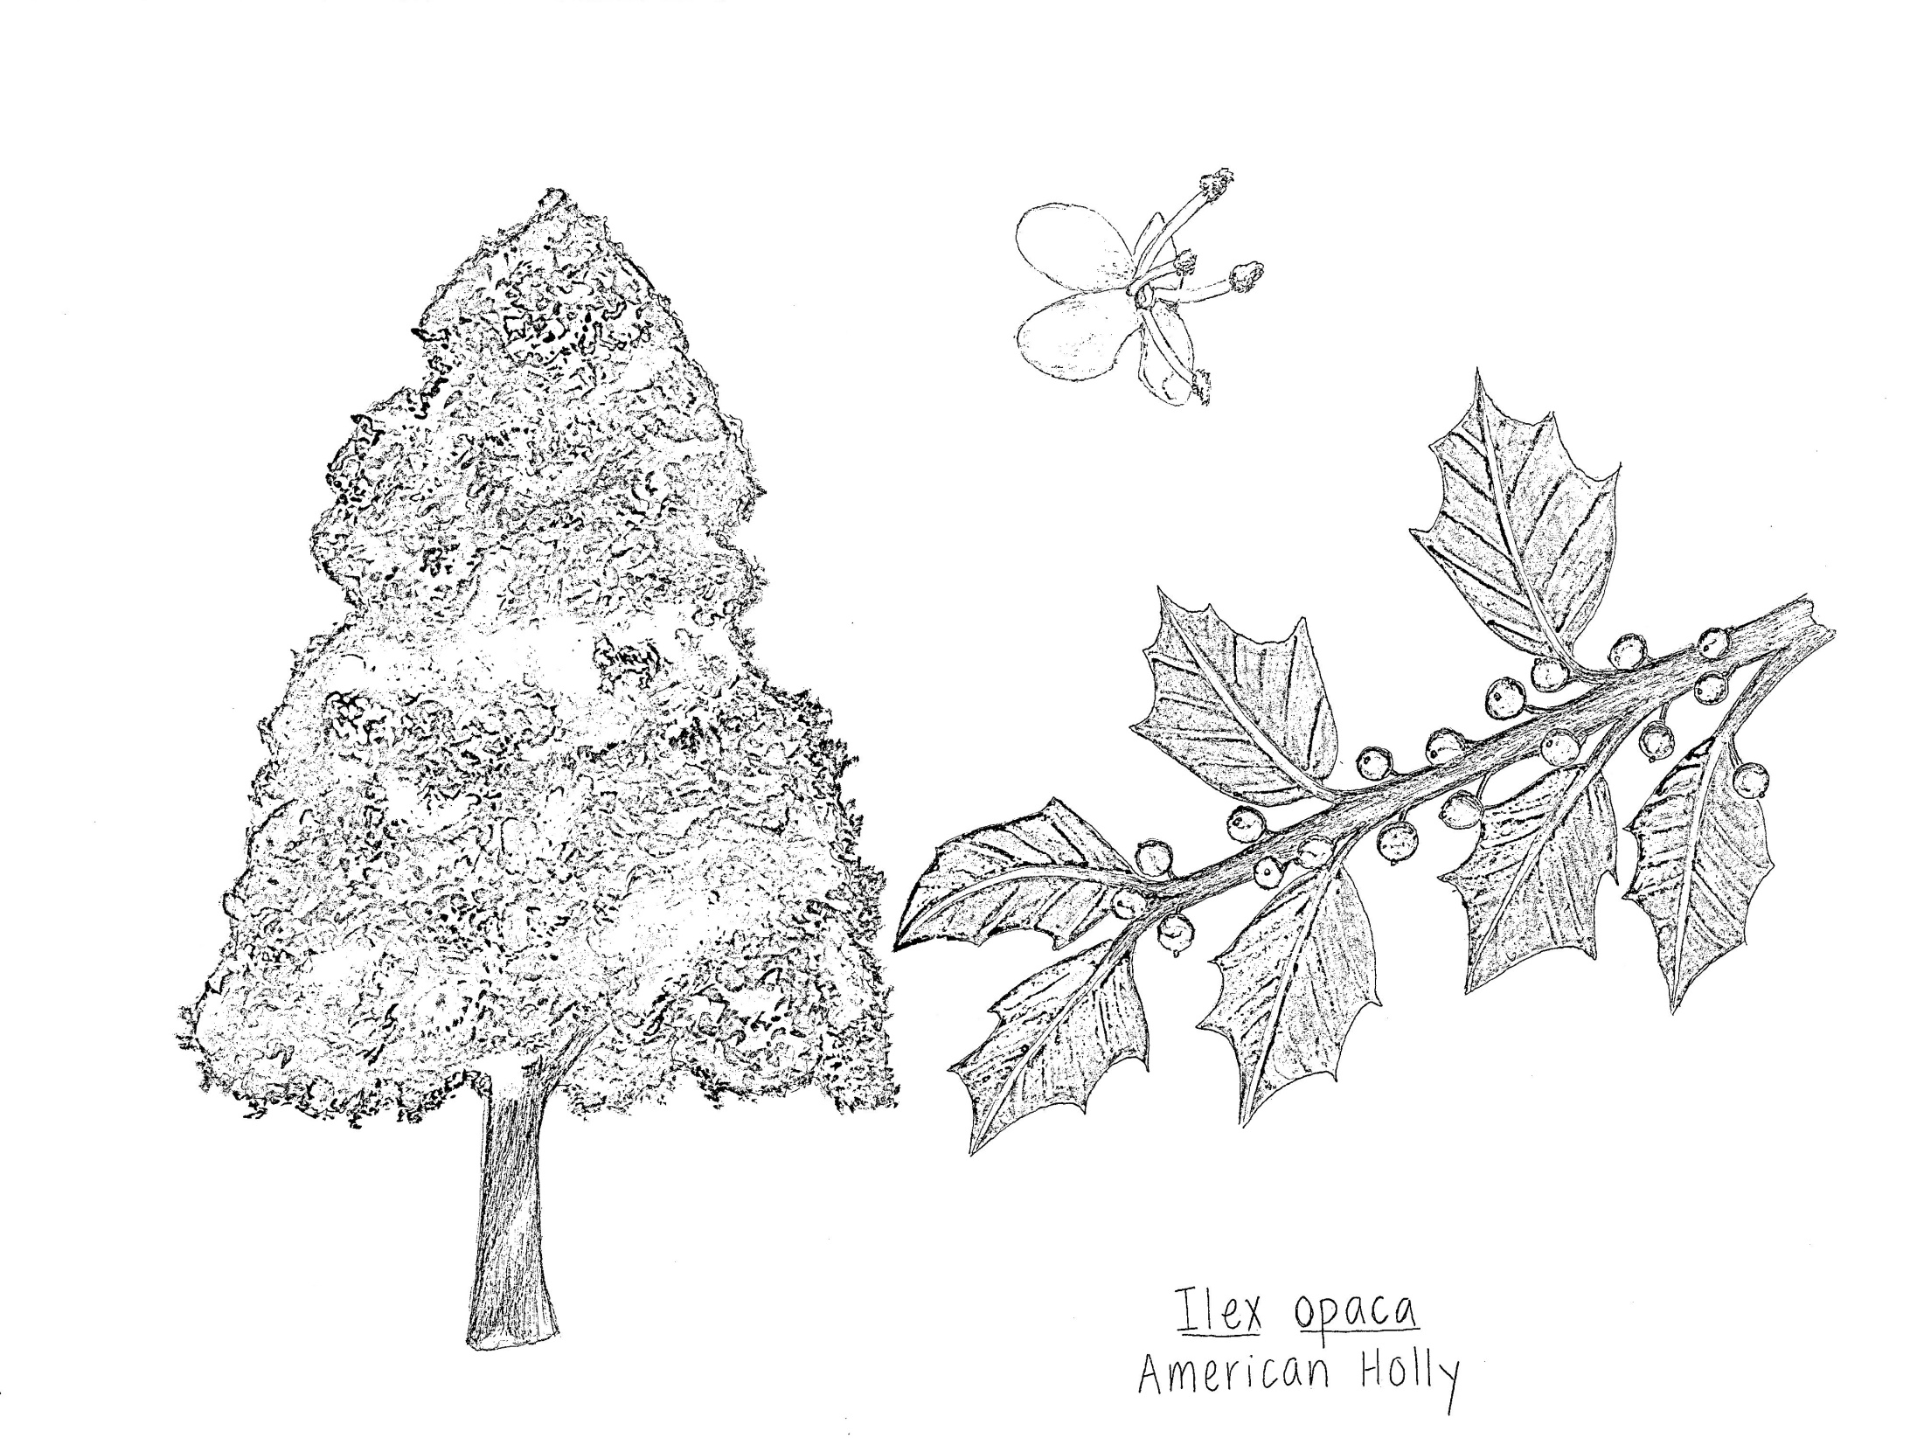

Some botanical illustrations, like the one above, include full view images of the specimen as well as close ups on things like leaves and flowers.