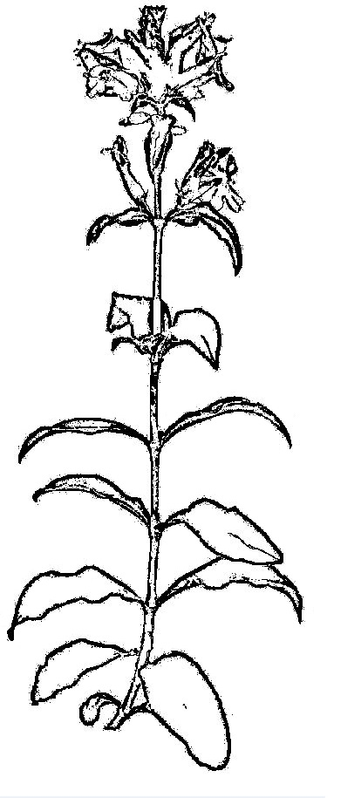

After a plant is collected it is pressed.

We remove any extra leaves that would get in the way of pressing the plant,

And place it in the plant press.

This plant has broad leaves and pretty, small flowers that blend in at the top.