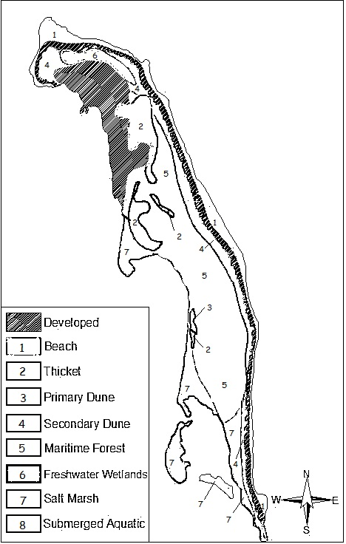
The Zones of Sandy Hook
Here is a map of the different zones of Sandy Hook, New Jersey.
Complete the map by assigning each number a different color, and coloring each part of the map with the color you assigned that number.
Finish the key by coloring each number square in the color that you assigned that number.

In this packet we are going to discuss the different zones on Sandy Hook. In each zone you will find different types of plant life. And so, on the following pages you will find information about different plants in each zone.

Thicket
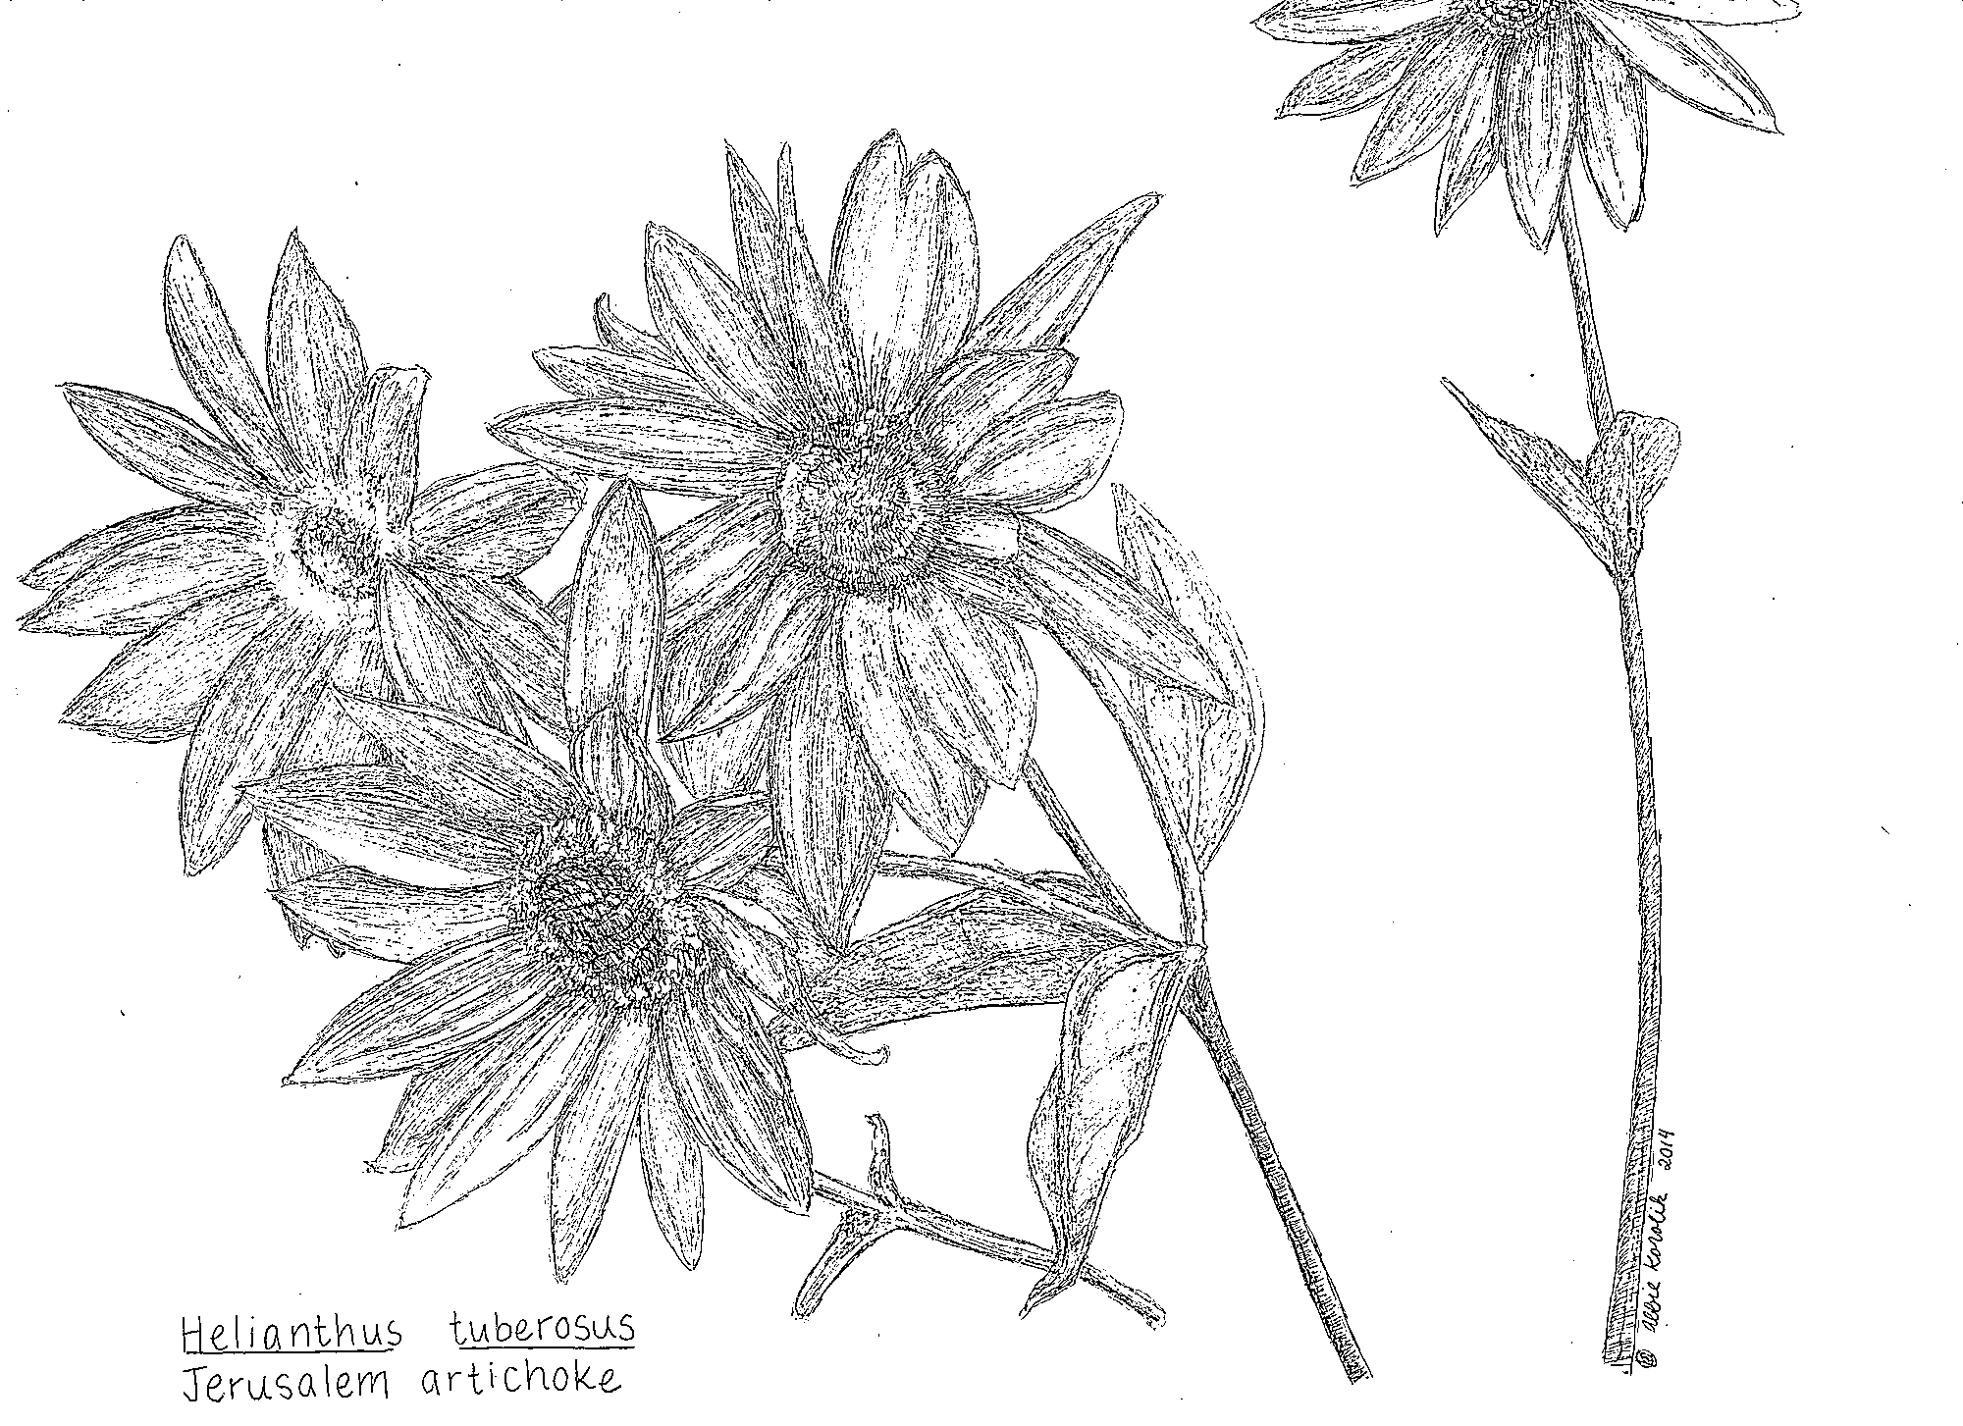
Jerusalem Artichoke (Helianthus tuberose)
- Appearance:
  - 4 to 10 ft tall
  - Yellow flowers between 1.5 to 3 inches in diameter
  - Blooms in fall
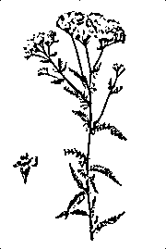
- Fun Fact: Can be grown as a food source (the tubers, structures of roots, are edible)

Yarrow (Achillea millefolium)
- Appearance:
  - Up to 3 ft tall
  - Evenly distributed leaves
  - Flowers between May and June
  - Produces small fruit
- Fun Fact: Can be used to help combat soil erosion

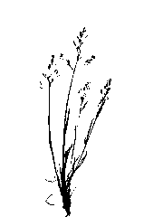
Primary Dunes
Upland Bentgrass (Agrostis perennans)
- Appearance:
  - Grows up to 3.5 ft tall
  - Alternating leaves, small green flowers
  - Flowers between July and October
- Fun Fact: Used on golf courses

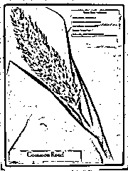
Common Reed (Phragmites australis)
- Appearance:
  - Grows up to 3 to 4 meters tall
- Fun Fact: Common Reed grows in beds that can be up to a kilometer wide

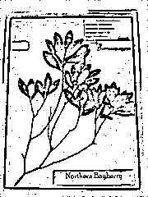
Now use the Sandy Hook Herbarium website to complete the rest of this packet by filling out important information on the lines provided!
Secondary Dunes
Beach Plum (Prunus Maritima)
- Appearance:
  - ________________________
  - ________________________
  - ________________________
  - ________________________
  - ________________________
- Fun Fact: _____________________
- _____________________________
- _____________________________

Canada Goldenrod (Solidago canadenis)
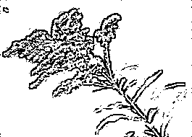
- Appearance:
  - ________________________
  - ________________________
  - ________________________
  - ________________________
  - ________________________
- Fun Fact: _____________________
- _____________________________
- _____________________________

Maritime Forest
American Holly (Ilex opaca)
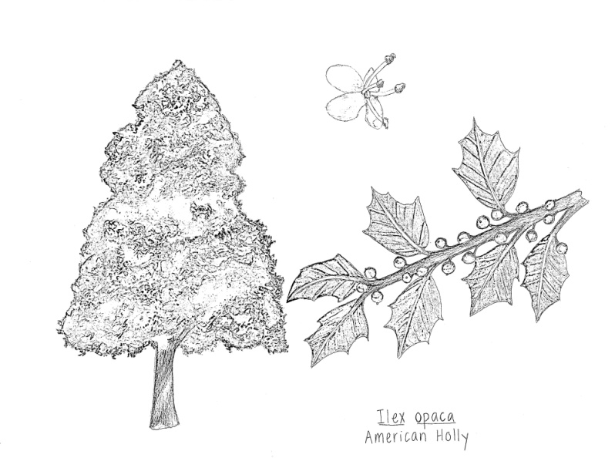
- Appearance:
  - ________________________
  - ________________________
  - ________________________
  - ________________________
  - ________________________
  - ________________________
  - ________________________
  - ________________________
- Fun Fact: _____________________
- _____________________________
- _____________________________

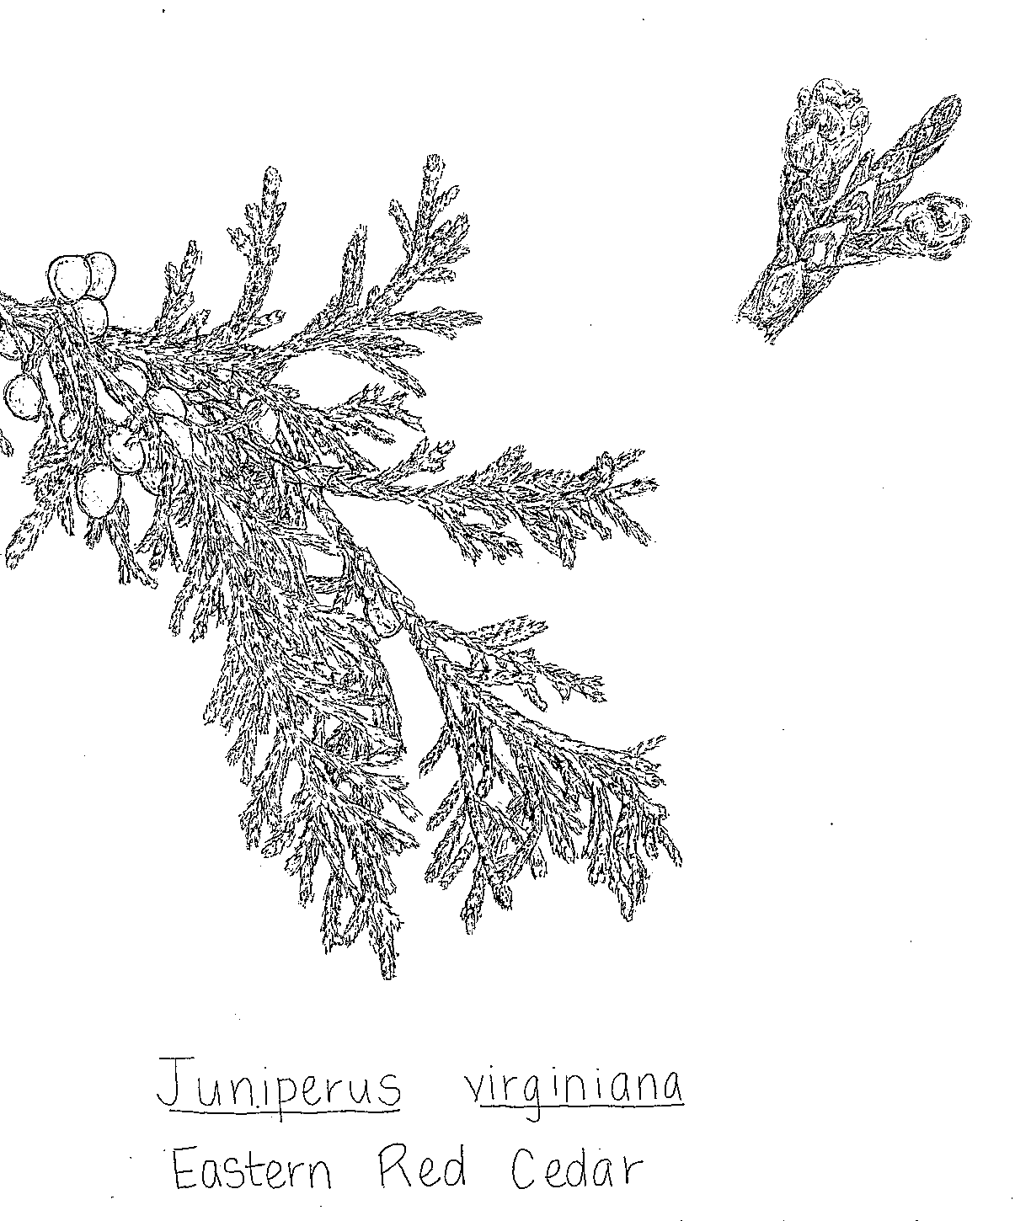
Juniper (Juniperus virginiana)
- Appearance:
  - ________________________
  - ________________________
  - ________________________
  - ________________________
  - ________________________
  - ________________________
  - ________________________
- Fun Fact: _____________________
- _____________________________
- _____________________________

Freshwater Wetlands
Juneberry (Amelanchier canadenis)
- Appearance:
  - ________________________
  - ________________________
  - ________________________
  - ________________________
  - ________________________
  - ________________________
  - ________________________
  - ________________________
- Fun Fact: _____________________
- _____________________________
- _____________________________

Lance Leaved Violet (Viola lanceolata)
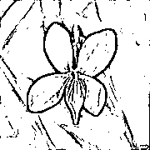
- Appearance:
  - ________________________
  - ________________________
  - ________________________
  - ________________________
  - ________________________
  - ________________________
  - ________________________
  - ________________________
- Fun Fact: _____________________
- _____________________________
- _____________________________

Salt Marsh
Salt marsh Cordgrass (Spartina alterniflora)
- Appearance:
  - ________________________
  - ________________________
  - ________________________
  - ________________________
  - ________________________
  - ________________________
  - ________________________
  - ________________________
- Fun Fact: _____________________
- _____________________________
- _____________________________
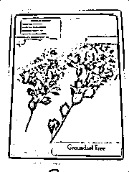
Sea-myrtle (Baccharis halimifolia)
- Appearance:
  - ________________________
  - ________________________
  - ________________________
  - ________________________
  - ________________________
  - ________________________
  - ________________________
  - ________________________
- Fun Fact: _____________________
- _____________________________
- _____________________________

