Your Very Own Plant Guide! (Packet 2)
Note: This packet is interactive and requires access to the Sandy Hook Interactive Herbarium Website, Sandyhookherbarium.org in order to be complete.

In this packet you will make your very own plant guide. The purpose of this guide is so that you can identify some commonly seen plants out in the field (outside where these plants are found). To complete this plant guide you will need to go online to Sandyhookherbarium.org and find the common names section. The link to the common name’s section can be found below:
http://sandyhookherbarium.org/plant-directory/common-name/
On the common names section you will find the names of the plants which have been included in this section. Click on the name which matches the one matching in this packet and begin to fill out the different pieces of information this packet asks for. Also, don’t forget to draw and color a picture of the plant in the box provided!
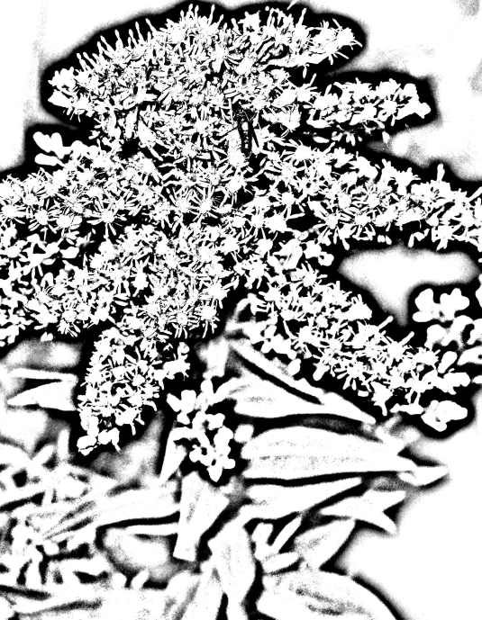
Plant Name: Seaside Goldenrod________________
Scientific Name: Solidago sempervirens__________
Location: Dunes, Salt/Brackish/Freshwater marsh__
Description: Perennial, grows anywhere from 3 to 6 ft
_____In height. dark green waxy leaves,
______Blooms clusters of yellow golden
________________________Flowers.

Plant Name: Juniper_________________________
Scientific Name:___________________________
Location:_________________________________
Description:_______________________________
_______________________________
_______________________________
_______________________________

Plant Name: Bayberry (Northern)______________
Scientific Name:___________________________
Location:_________________________________
Description:_______________________________
_______________________________
_______________________________
_______________________________

Plant Name: American Holly___________________
Scientific Name:___________________________
Location:_________________________________
Description:_______________________________
_______________________________
_______________________________
_______________________________

Plant Name: Beach Plum______________________
Scientific Name:___________________________
Location:_________________________________
Description:_______________________________
_______________________________
_______________________________
_______________________________

Pick two other plants from the Sandy Hook Interactive Herbarium website that you would like to have in your plant guide!

Plant Name: _______________________________
Scientific Name:___________________________
Location:_________________________________
Description:_______________________________
_______________________________
_______________________________
_________________________________________

Plant Name: _______________________________
Scientific Name:___________________________
Location:_________________________________
Description:_______________________________
_______________________________
_______________________________
_______________________________

